**CSBD5590 Lab Assignment 3 Report**

Following the tutorial the glassfish server is installed on the oepe-juno eclipse as shown.

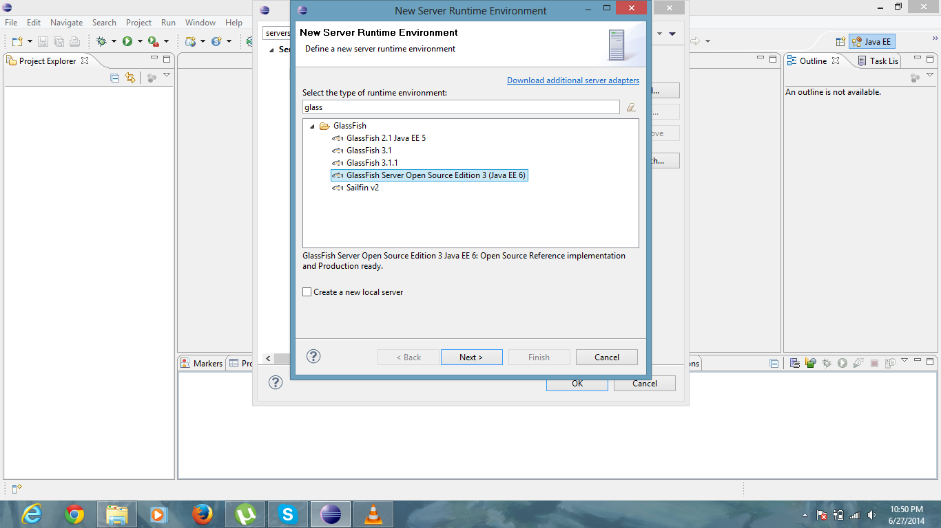

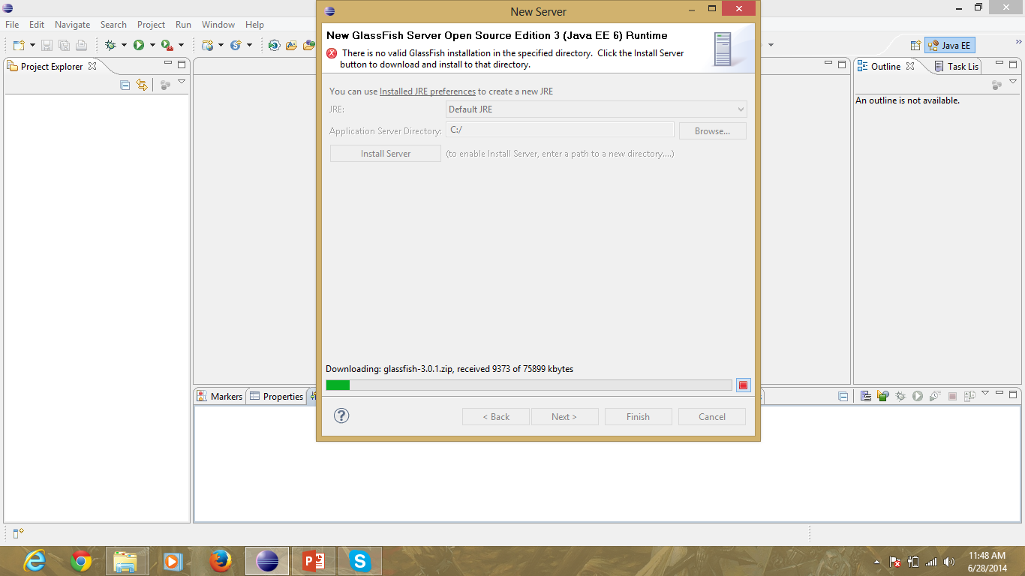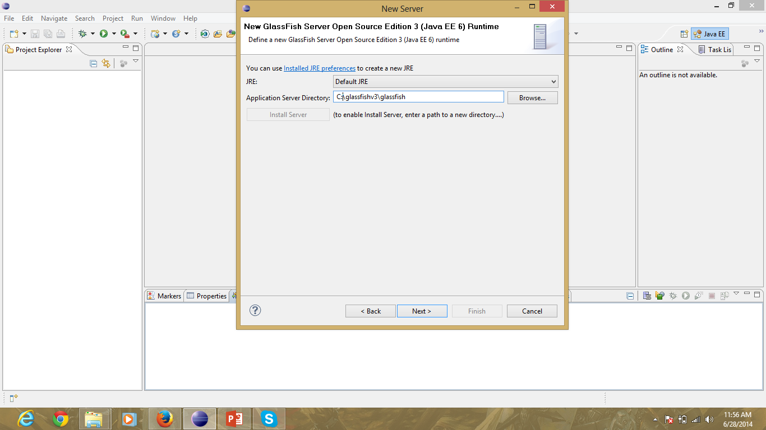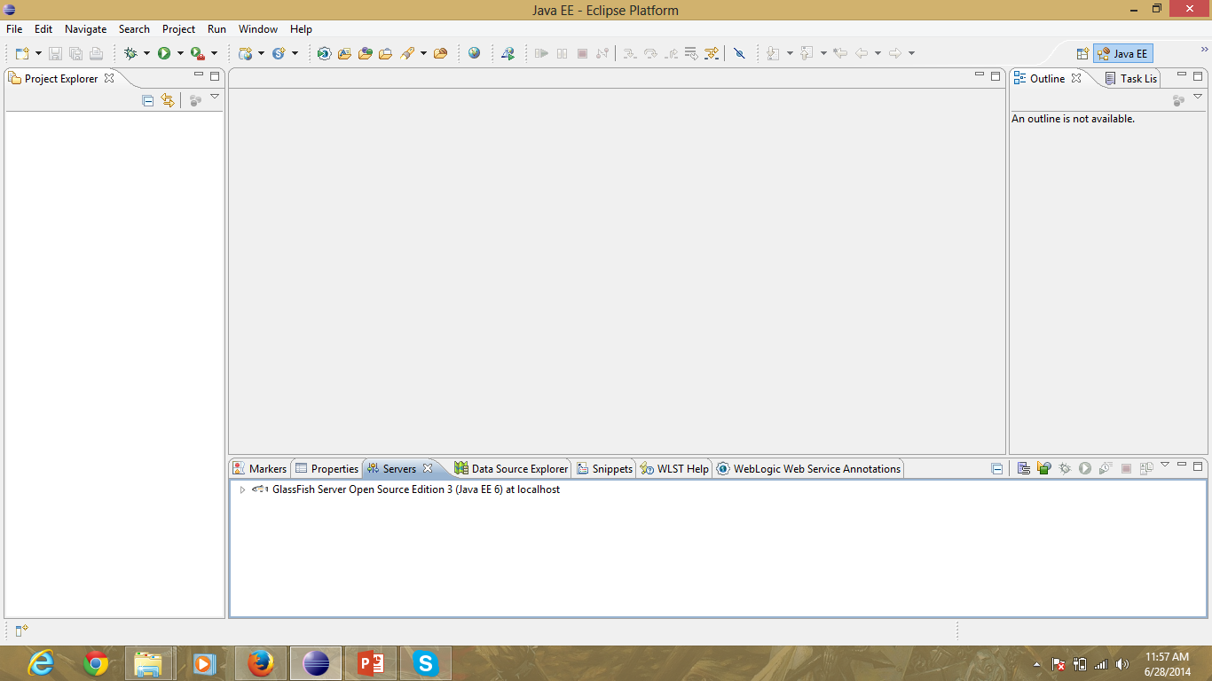

The glassfish server was also installed on the cloudera server as shown.

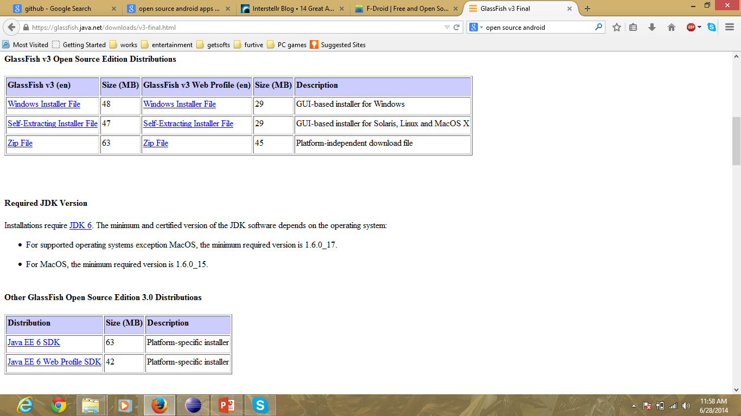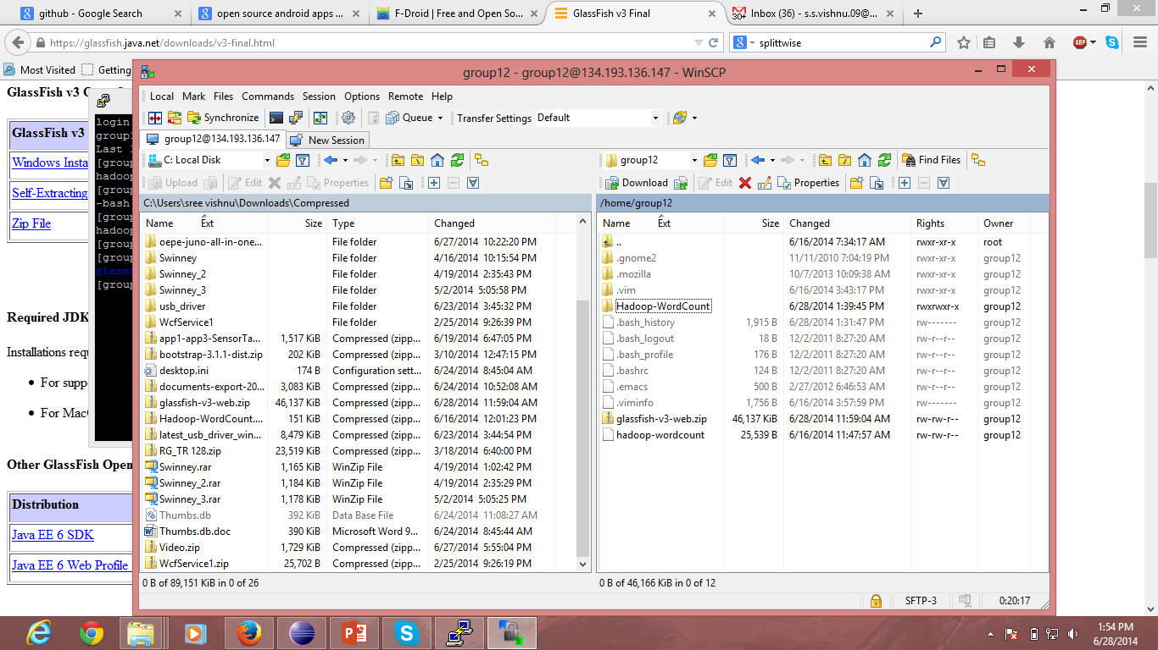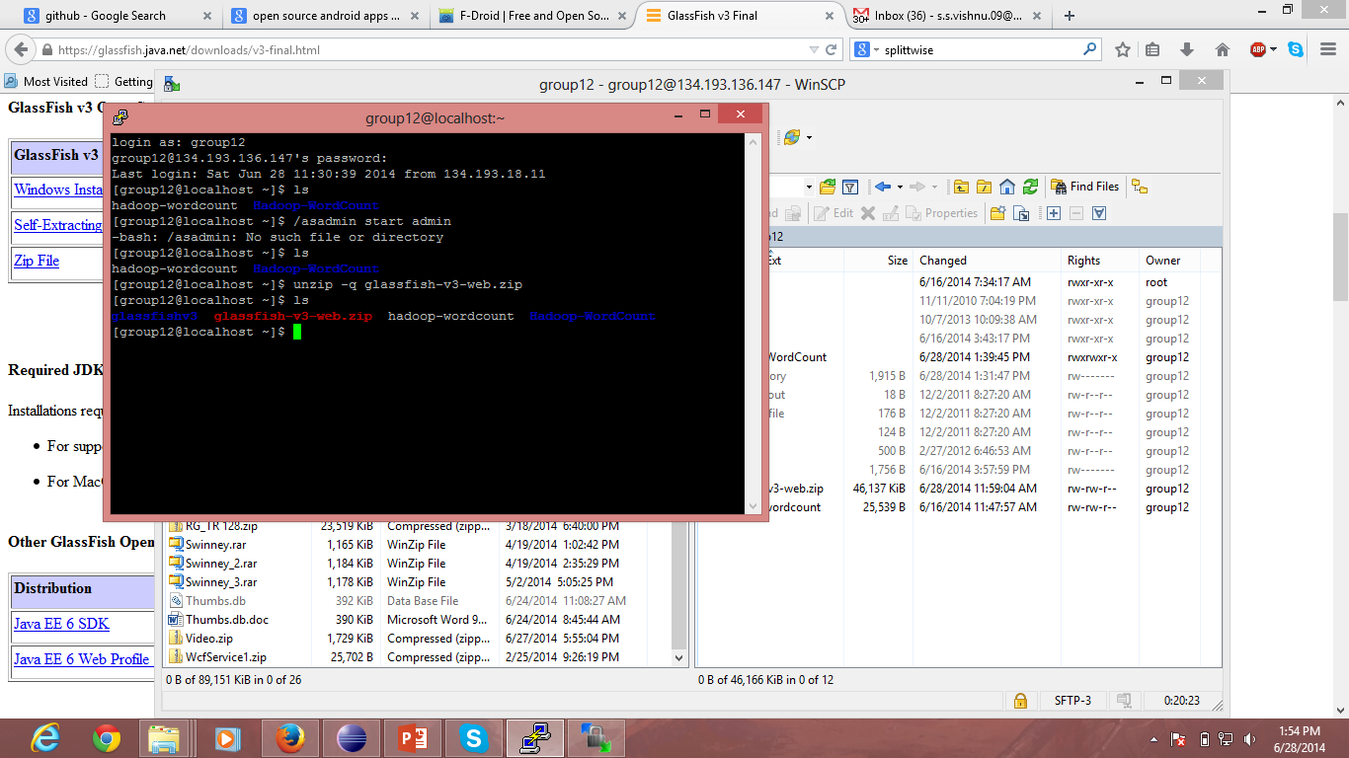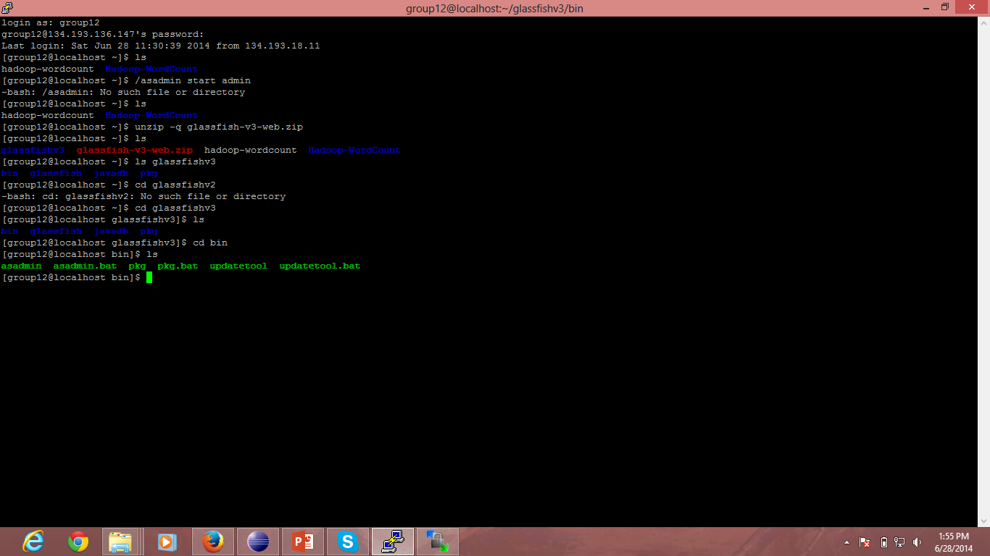

The application can be deployed on to the server using the interface shown below.

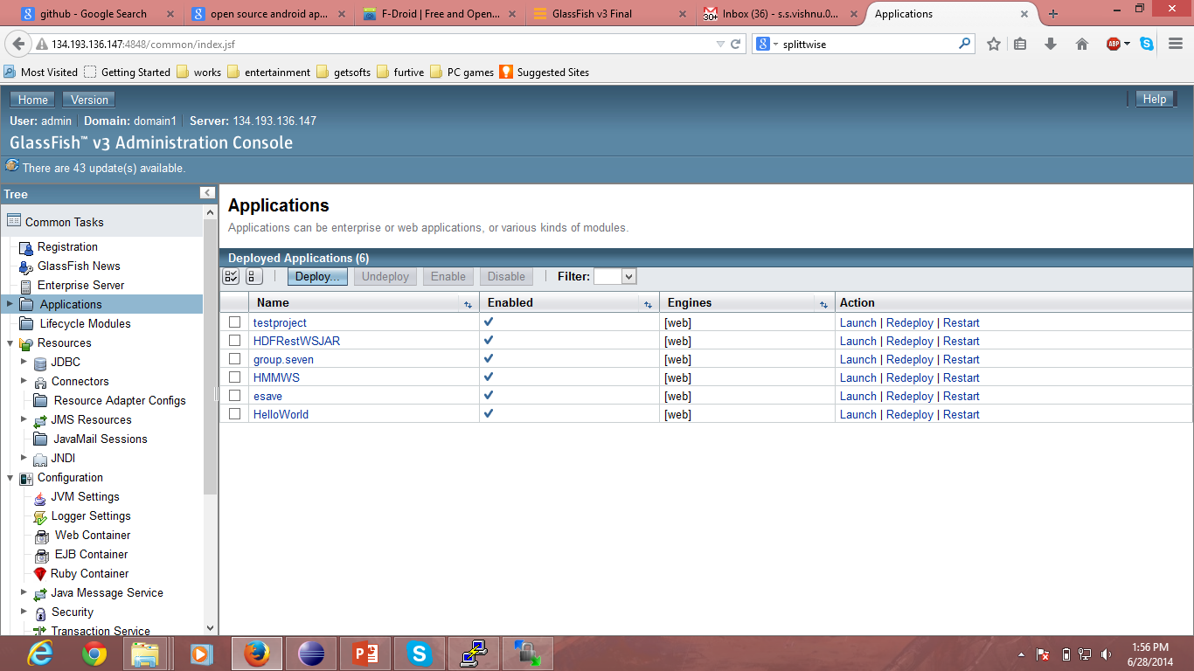

Now, to create a webservice, A new Dyanamic web project was selected.

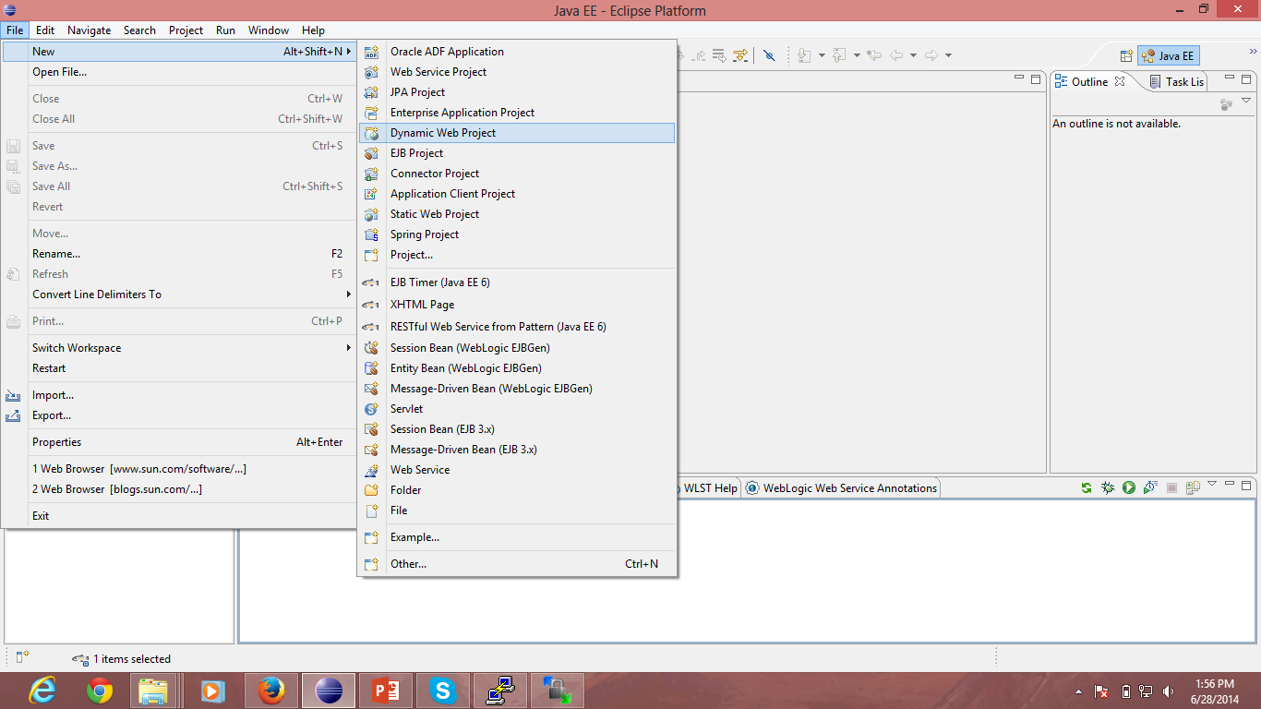

And steps were followed to create the web project successfully.

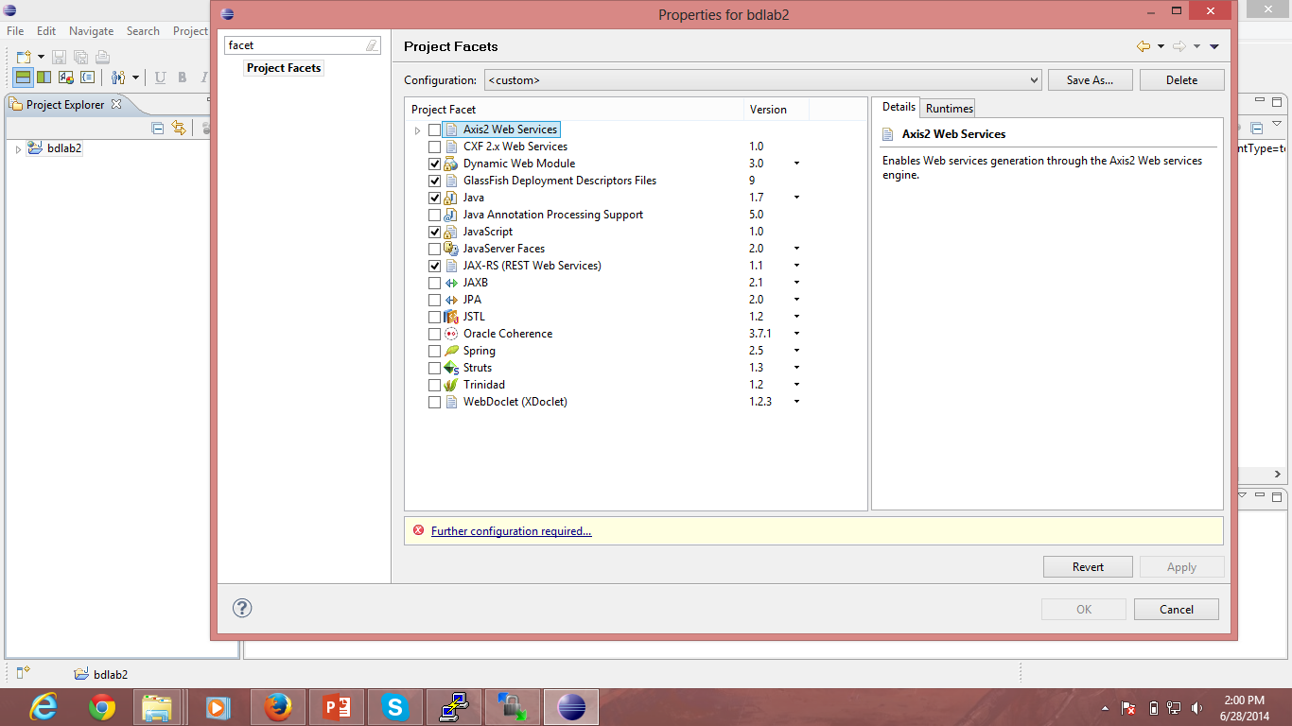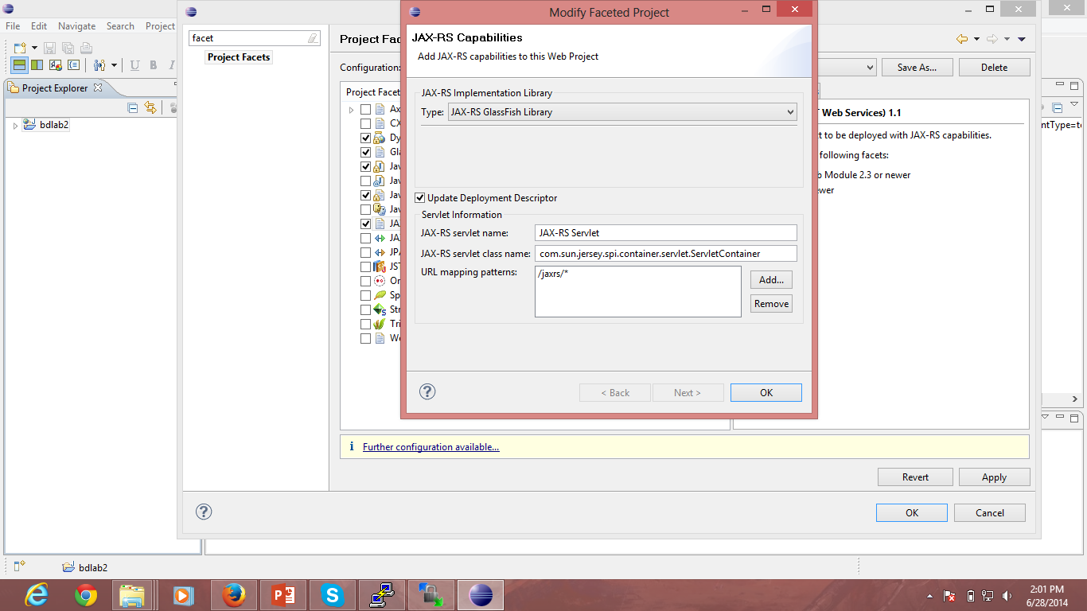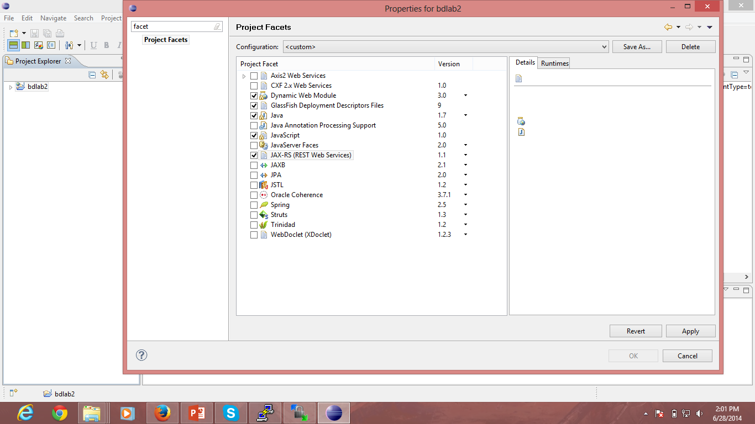

Now restful service was added to the web project as shown: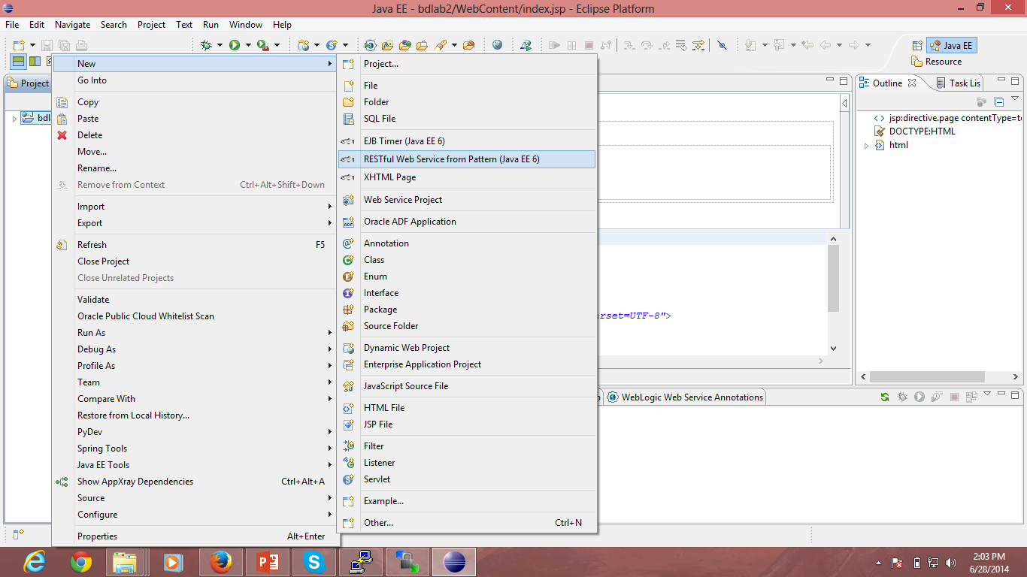

The required web services were coded:

I have created the webservice in such a way that the parameters are only the tablename for each of the method as using only one parameter helps to develop the android app easily.

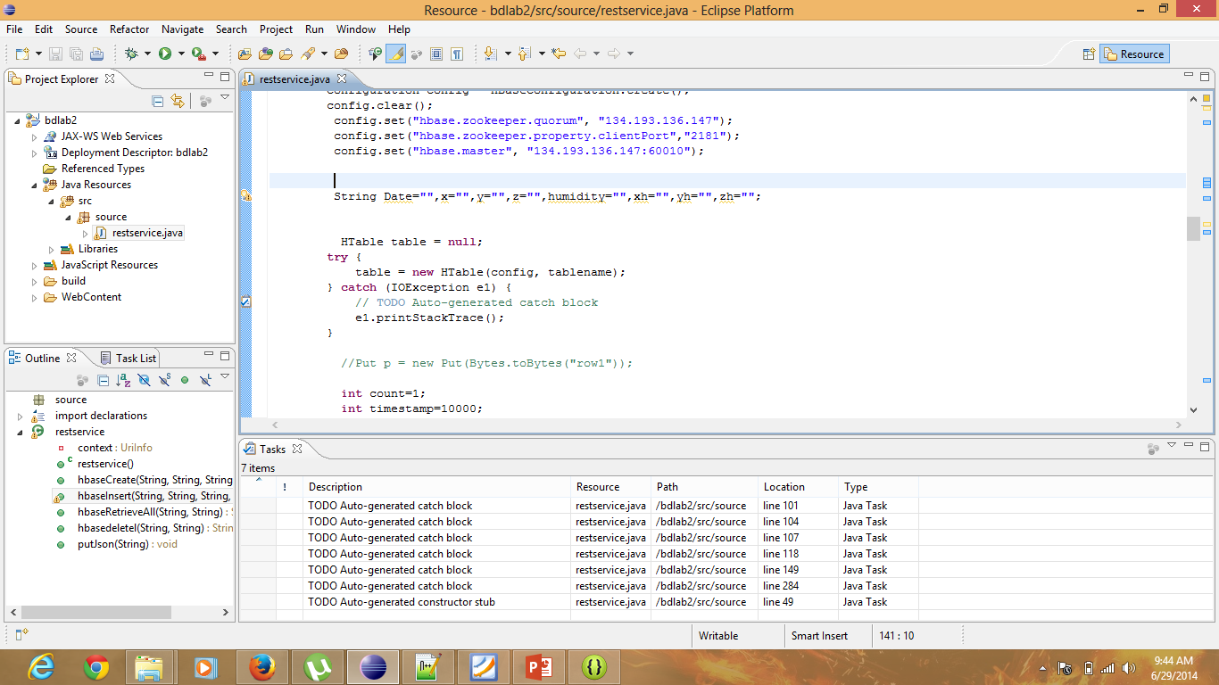

Then the web service was published onto the glass fish server as shown.

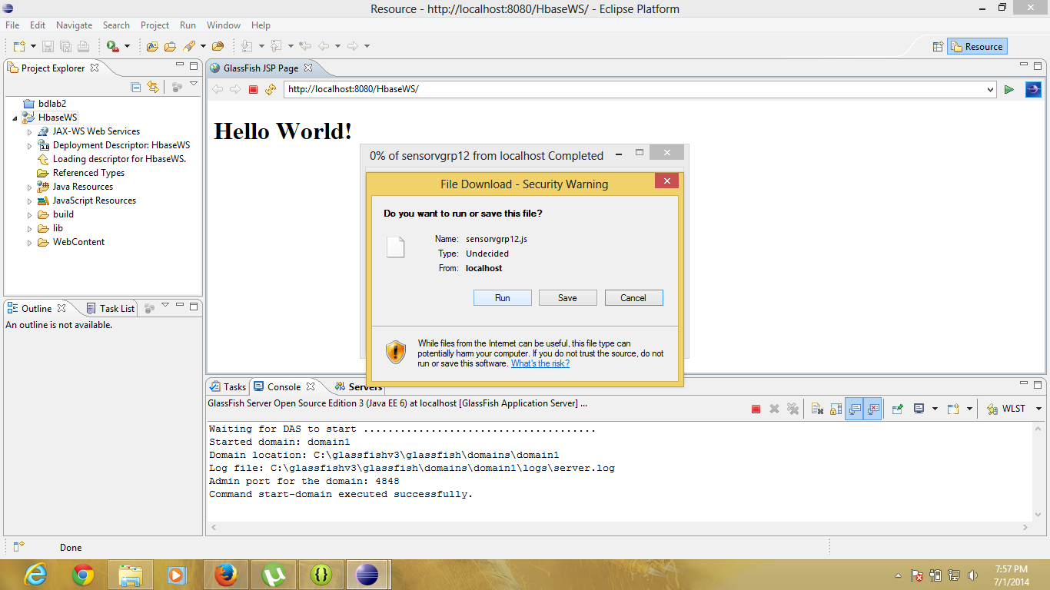

The hbaseCreate method was called and the table was created in the hbase using the file sensorv.txt which was present in the local directory as the service was run locally.

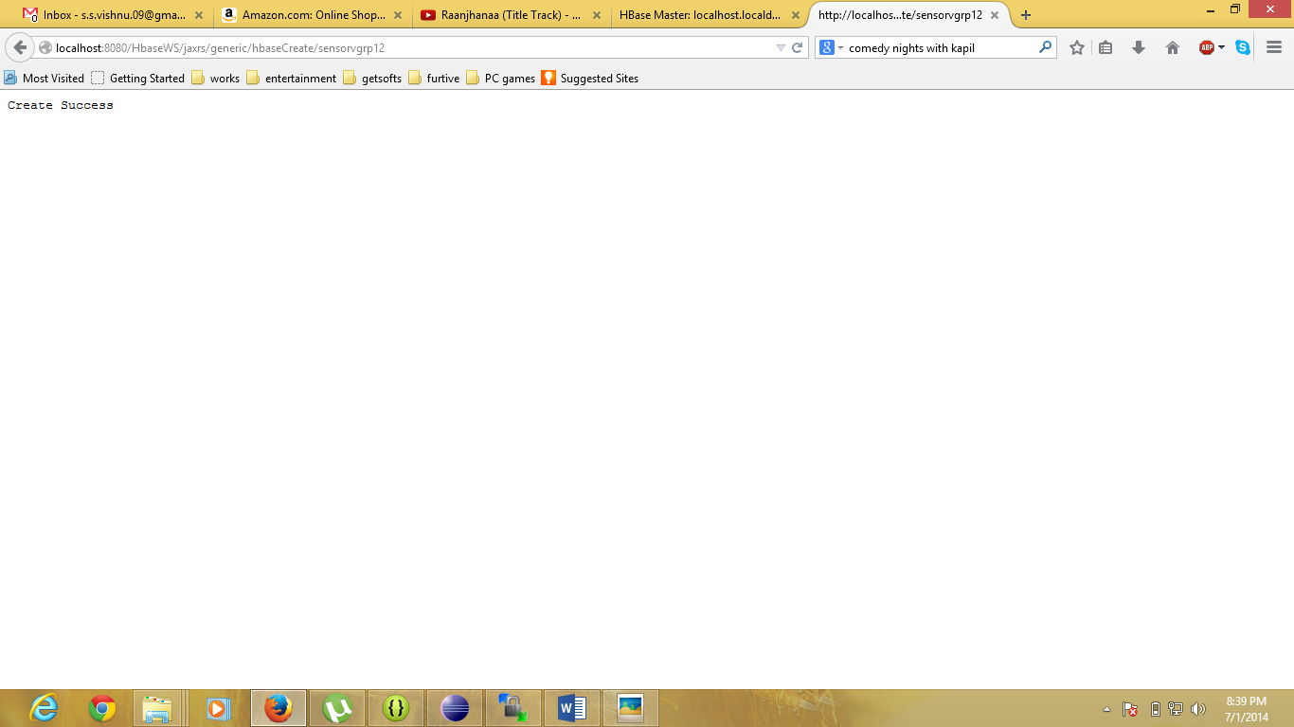

Now, the insert method was called to insert all the data in sensorv.txt into hbase.

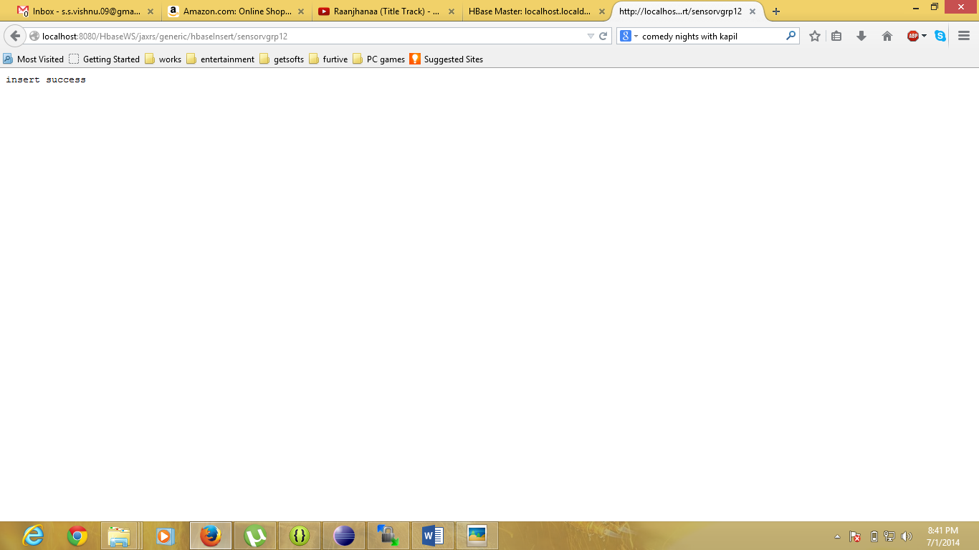

Now, the retreiveall method was called.

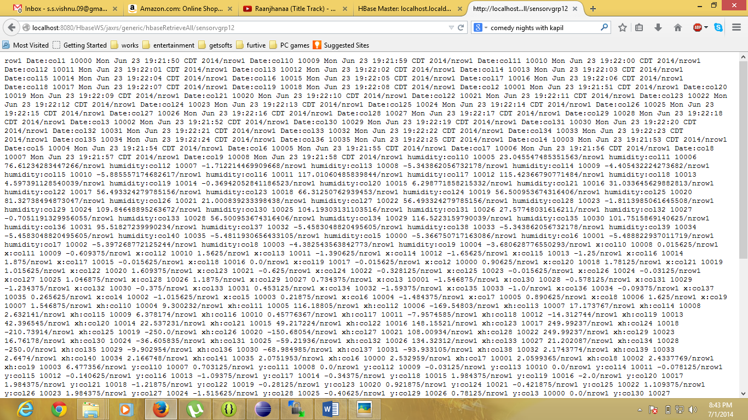

Now, the table was deleted using the deletetable method.

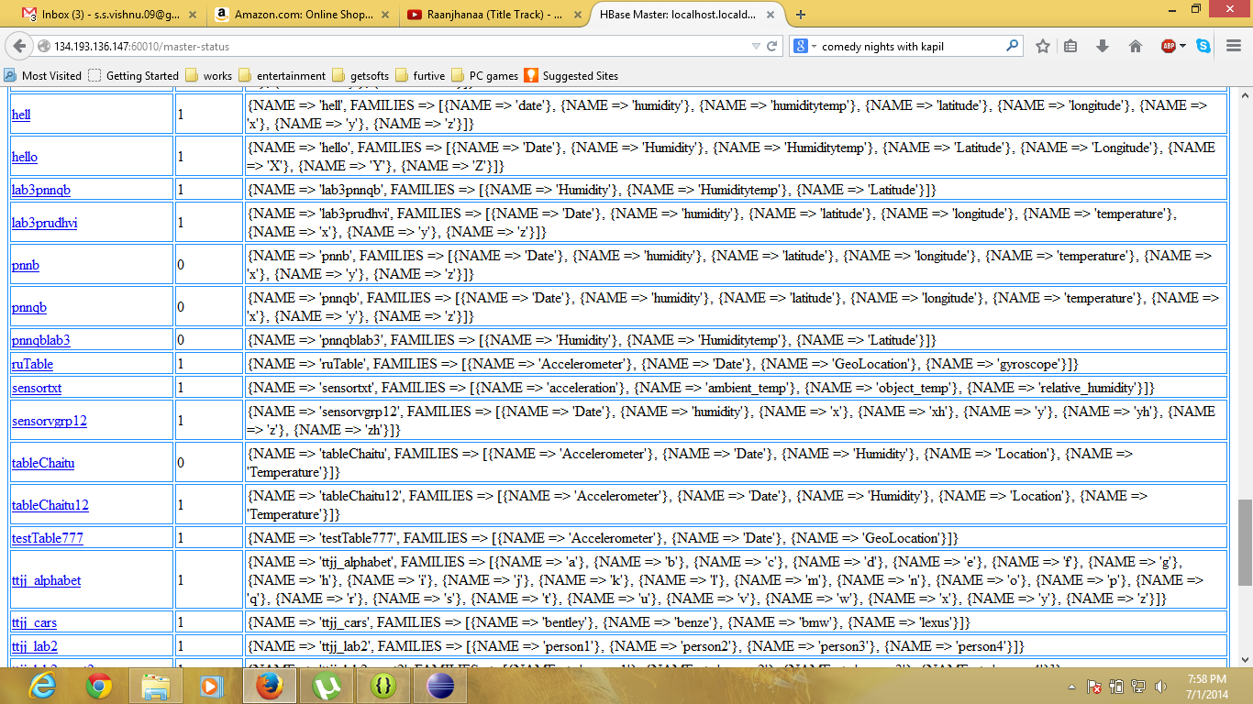

After calling the method:

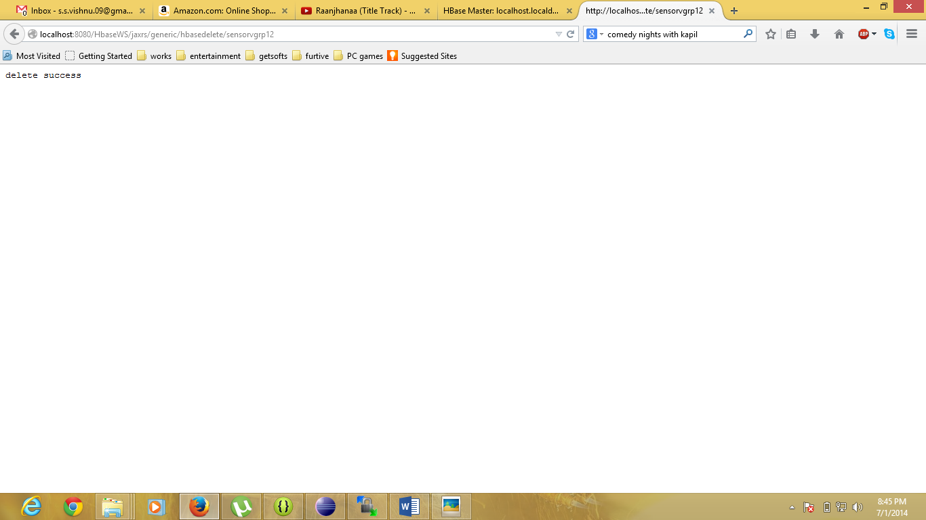

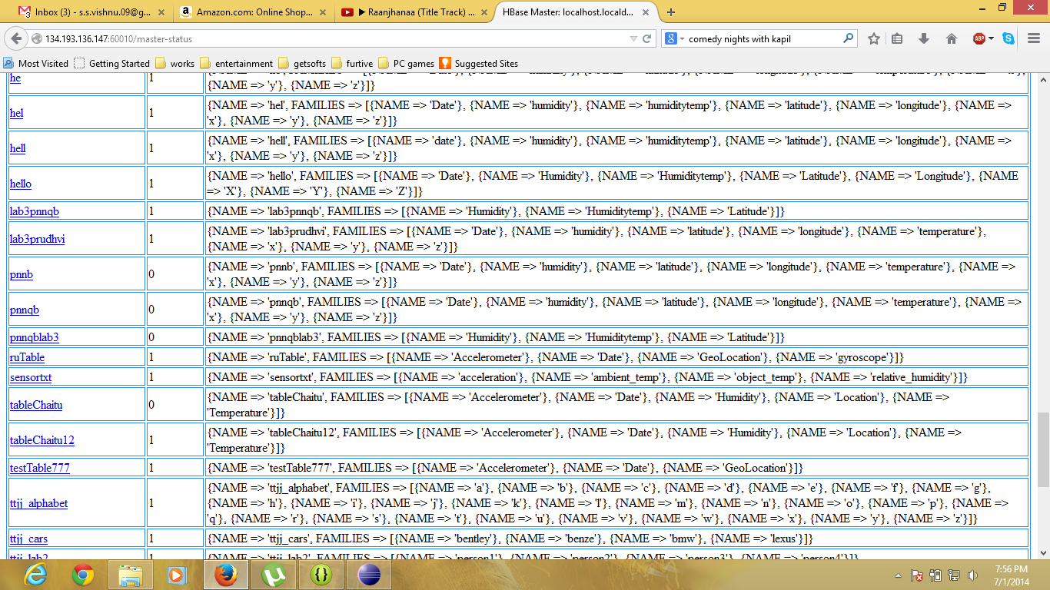

**Sree Vishnu Satarajupalli**

**16162426**